**Module 1) – Foundation**

Do search for web-site, http, URL etc given topics in lecture.

* Website is a combination of web pages. There are so many websites on internet. i.e. [www.tops-int.com](http://www.tops-int.com)
* HTTP is the protocol for transferring the hyper text
* URL is the method to find any website from all over internet network.

**Module 2) Fundamentals of IT**

Do search for domain, hosting, SEO etc.

* Domain is the unique name of each website.
* Hosting is the platform to launch website.
* SEO stands for Search Engine Optimization. Which use to push up the website on Google.

**Module 3) HTML**

**1. Are the HTML tags and elements the same thing?**

**Ans.** No, HTML tags are the basic tag to create main module of HTML, while elements includes start tag, it’s content and an end tag.

**Code :**

<!DOCTYPE html>

<html lang="en">

<head>

    <meta charset="UTF-8">

    <meta name="viewport" content="width=device-width, initial-scale=1.0">

    <title>Document</title>

</head>

<body>

    <p>This is an Element</p>

</body>

</html>

<p> This is an Element </p>

* From the starting tag to ending tag is called as an element.
* <p> is the Starting Tag and </p> is the Ending Tag while “This is an Element” is the content.

**Output :**

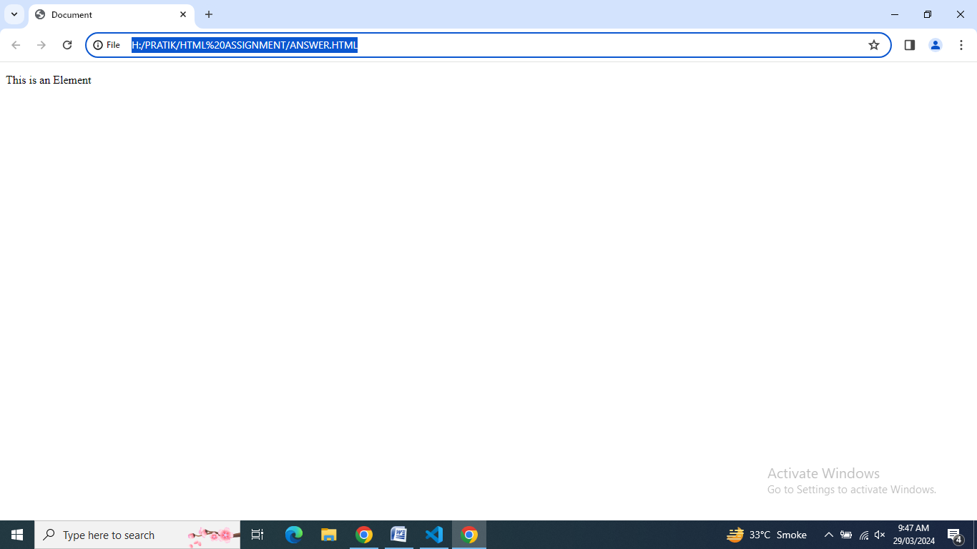

**2. What are tags and attributes in HTML?**

**Ans.** HTML is used to maintain the HTML elements and attributes are used to maintain characteristic of an HTML element in detail.

**Code :**

<!DOCTYPE html>

<html lang="en">

<head>

    <meta charset="UTF-8">

    <meta name="viewport" content="width=device-width, initial-scale=1.0">

    <title>Document</title>

</head>

<body>

    <img src="img2 - Copy.jpg" height="100%" width="800px">

    <br>

    <a href="https://www.google.com">Google</a>

</body>

</html>

**Output :**

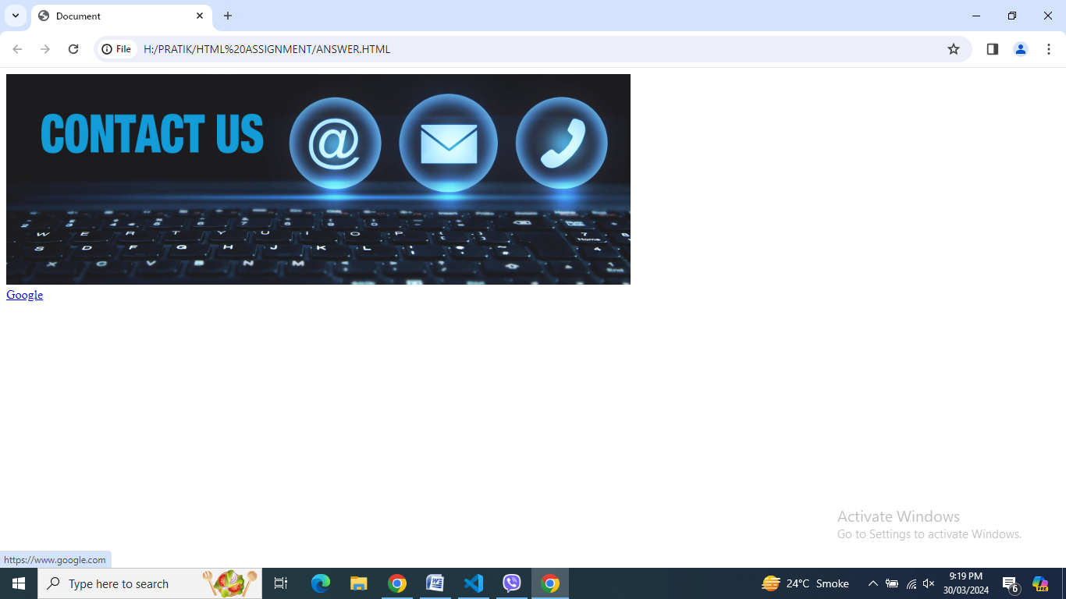

**3. What are void elements in HTML? With Example.**

**Ans.** Single tags are known as void elements which has no end tag. i.e. <br>, <hr>, <image> etc.

**Code :**

<!DOCTYPE html>

<html lang="en">

<head>

    <meta charset="UTF-8">

    <meta name="viewport" content="width=device-width, initial-scale=1.0">

    <title>Document</title>

</head>

<body>

  <img src="IMAGES/img2.jpg" height="100%" width="800px">

    <br>

    <hr>

<img src="IMG1.jpg" width="500px">

</body>

</html>

**Output :**

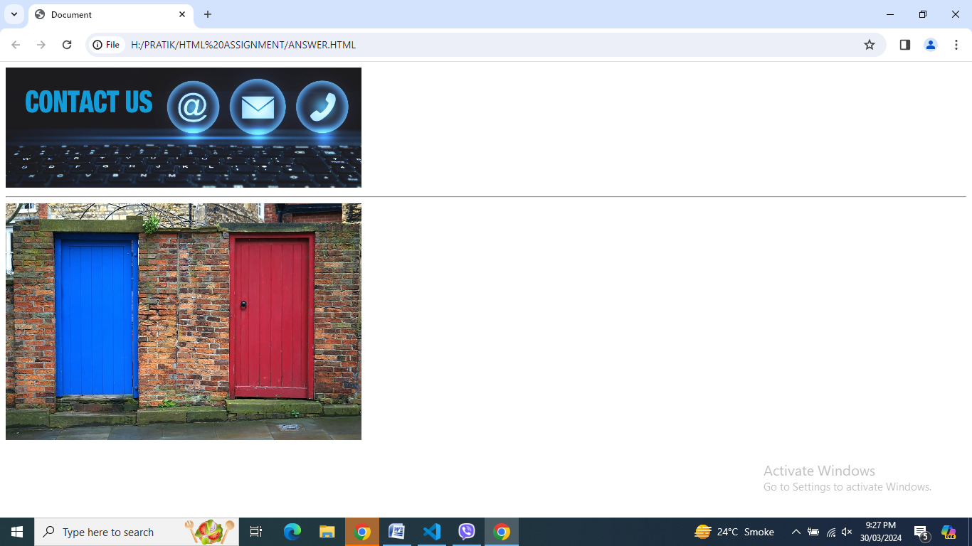

**4. What are HTML Entities? With Example.**

**Ans.** HTML entities is used to display reserved and invisible character. It’s starts with & sign and ends with ;

**Code :**

<!DOCTYPE html>

<html lang="en">

<head>

    <meta charset="UTF-8">

    <meta name="viewport" content="width=device-width, initial-scale=1.0">

    <title>Document</title>

</head>

<body>

    <a href="https://www.google.com">Google</a><br>

    &gt;<br>

    &nbsp; &nbsp; &lt;<br>

    &copy;<br>

    &reg;

</body>

</html>

**Output :**

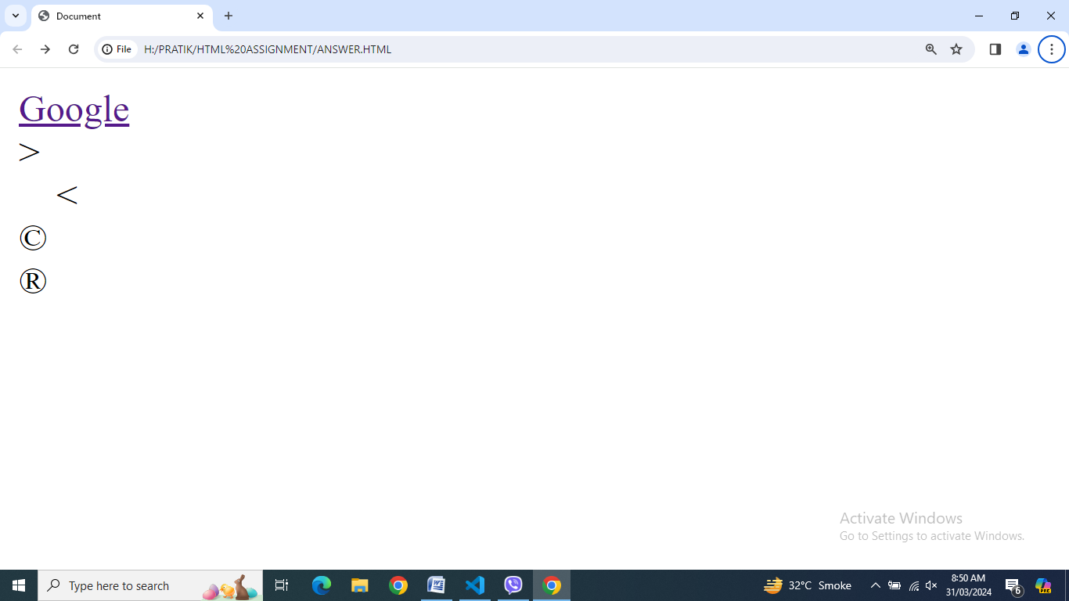

**5. What are different types of lists in HTML? With Example.**

**Ans.** There are three types of list in HTML

1. Ordered List – OL [ Also known as Numbered List ]
2. Unordered List – UL [ Also known as Bulleted List ]
3. Description List – DL [ Also known as Definition List ]

**Code :**

<!DOCTYPE html>

<html lang="en">

<head>

    <meta charset="UTF-8">

    <meta name="viewport" content="width=device-width, initial-scale=1.0">

    <title>Document</title>

    <style>

        .pc {

            background-color: brown;

            color: white;

            border: 2px solid black;

            width: 50%;

            margin: 20px;             padding: 20px;

        }

    </style>

    <style>

        .pc1 {

            background-color: blue;

            color: white;

            border: 2px solid black;

            width: 50%;

            margin: 20px;            padding: 20px;

        }

    </style>

</head>

<body>

    <div class="pc">

        <h2>486 Computer</h2>

        <p>486 Computer was my first Computer in 1996.</p>

    </div>

    <div class="pc1">

        <h2>Core I5 Computer</h2>

        <p>Core I5 Computer is my working Computer.</p>

    </div>

    <div class="pc">

        <h2>Virtual Machine</h2>

        <p>Virtual Machine is my Dream Machine</p>

    </div>

</body>

</html>

**Output :**

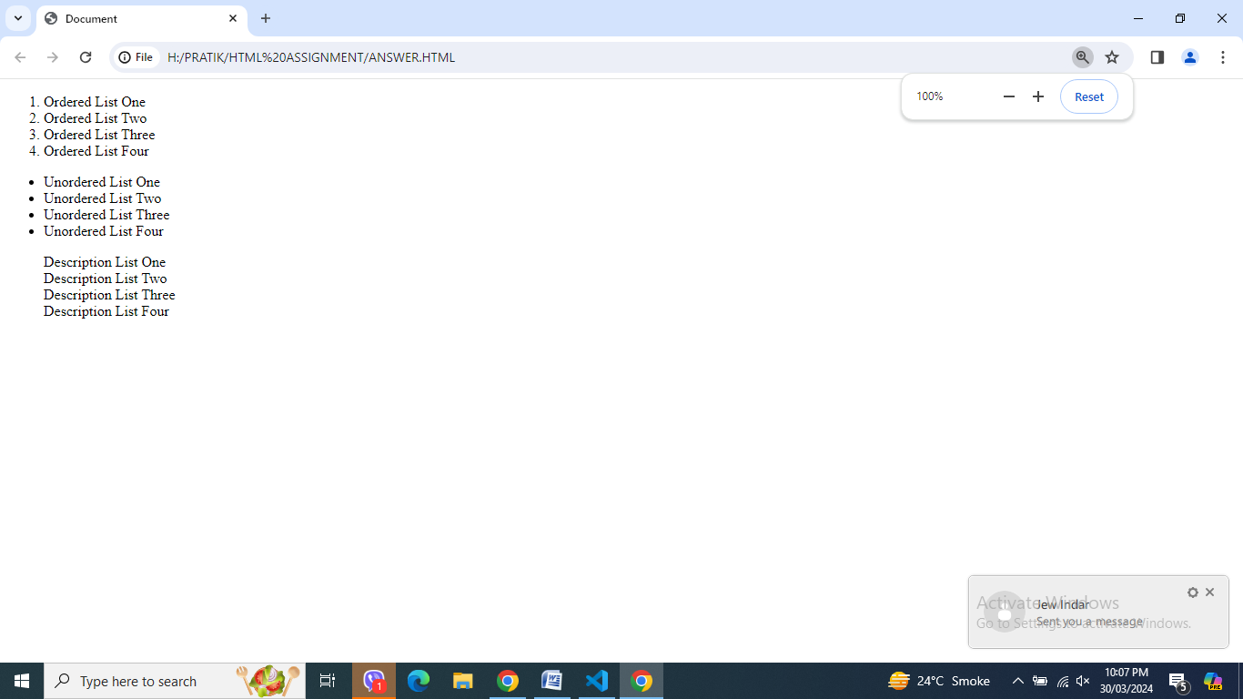

**6. What is the ‘class’ attribute in HTML? With Example.**

**Ans.** The class attribute state one or more class name for an element.

**Code :**

<!DOCTYPE html>

<html lang="en">

<head>

    <meta charset="UTF-8">

    <meta name="viewport" content="width=device-width, initial-scale=1.0">

    <title>Document</title>

    <style>

        .pc{

            background-color: brown;

            color: white;

            width: 50%;

            margin: 20px;

            padding: 20px;

        }

        .pc1{

            background-color: blue;

            color: white;

            width: 50%;

            margin: 20px;

            padding: 20px;

        }

    </style>

</head>

<body>

    <div class="pc">

        <h2>486 Computer</h2>

        <p>486 Computer was my first Computer in 1996.</p>

    </div>

    <div class="pc1">

        <h2>Core I5 Computer</h2>

        <p>Core I5 Computer is my working Computer.</p>

    </div>

    <div class="pc">

        <h2>Virtual Machine</h2>

        <p>Virtual Machine is my Dream Machine</p>

    </div>

</body>

</html>

**Output :**

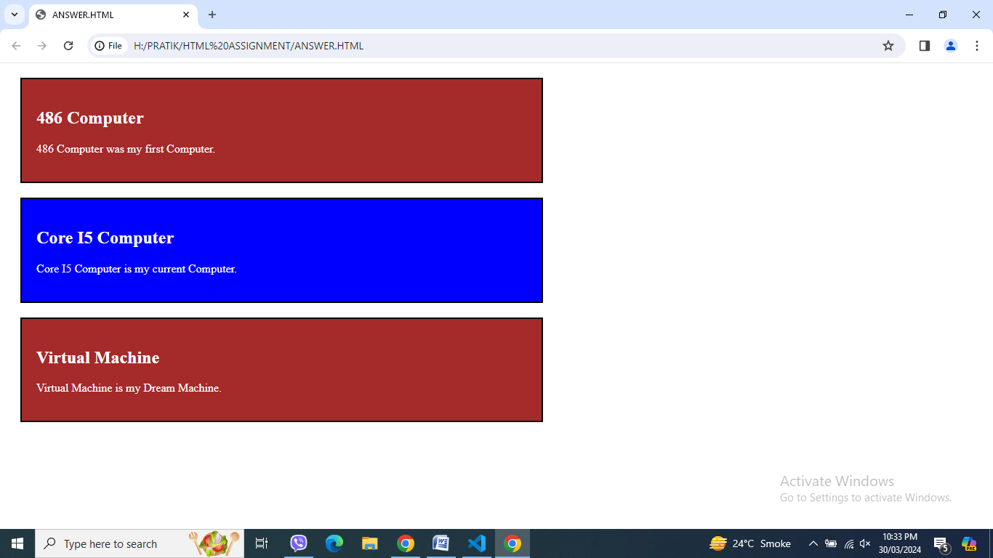

**7. What is the difference between the ‘id’ attribute and the ‘class’ attribute of HTML elements? With Example.**

**Ans.**

|  |  |
| --- | --- |
| Id | Class |
| id’s are unique. | Classes are not unique |
| id attribute is used only with one HTML element. | Class attribute is used with multiple HTML element |
| id declared with # ( hash ) symbol | Class declared with . ( dot ) symbol |

**Code :**

<!<!DOCTYPE html>

<html lang="en">

<head>

    <meta charset="UTF-8">

    <meta name="viewport" content="width=device-width, initial-scale=1.0">

    <title>Document</title>

    <style>

        .pc {

            background-color: brown;

            color: white;

            width: 50%;

            margin: 20px;            padding: 20px;

        }

    </style>

    <style>

        .pc1 {

            background-color: skyblue;            color: black;

            width: 50%;

            margin: 20px;            padding: 20px;

        }

    </style>

</head>

<body>

    <div class="pc">

        <h2>486 Computer</h2>

        <p>486 Computer was my first Computer in 1996.</p>

    </div>

    <div class="pc1">

        <h1 id="myheader">My Header</h1>

    </div>

    <div class="pc1">

        <h2 id="myheader">My Header</h2>

    </div>

</body>

</html>

**Output :**

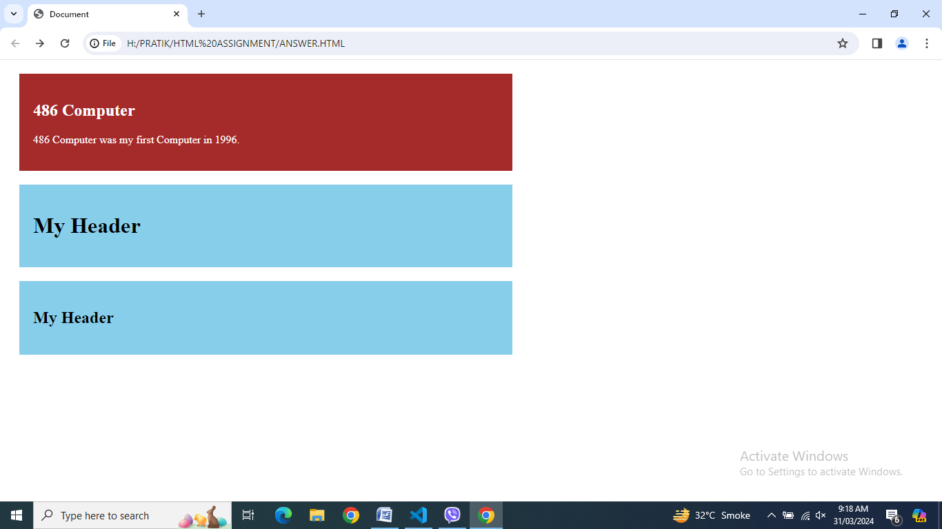

**8. What are the various formatting tags in HTML?**

**Ans.** There are several types formatting tags in HTML.

**Code :**

<!DOCTYPE html>

<html lang="en">

<head>

    <meta charset="UTF-8">

    <meta name="viewport" content="width=device-width, initial-scale=1.0">

    <title>Document</title>

</head>

<body>

    This is <b>Bold </b>Tag Example<br>

    This is <strong>Important </strong>Tag Example<br>

    This is <i>Italic </i>Tag Example<br>

    This is <em>Emphasized </em>Tag Example<br>

    This is <mark>Marked </mark>Tag Example<br>

    This is <small>Smaller </small>Tag Example<br>

    This is <del>Deketed </del>Tag Example<br>

    This is <ins>Insereted </ins>Tag Example<br>

    This is N<sup>2</sup> Superscript Tag Example<br>

    This is H<sub>2</sub>O SubscriptTag Example<br>

</body>

</html>

**Output :**

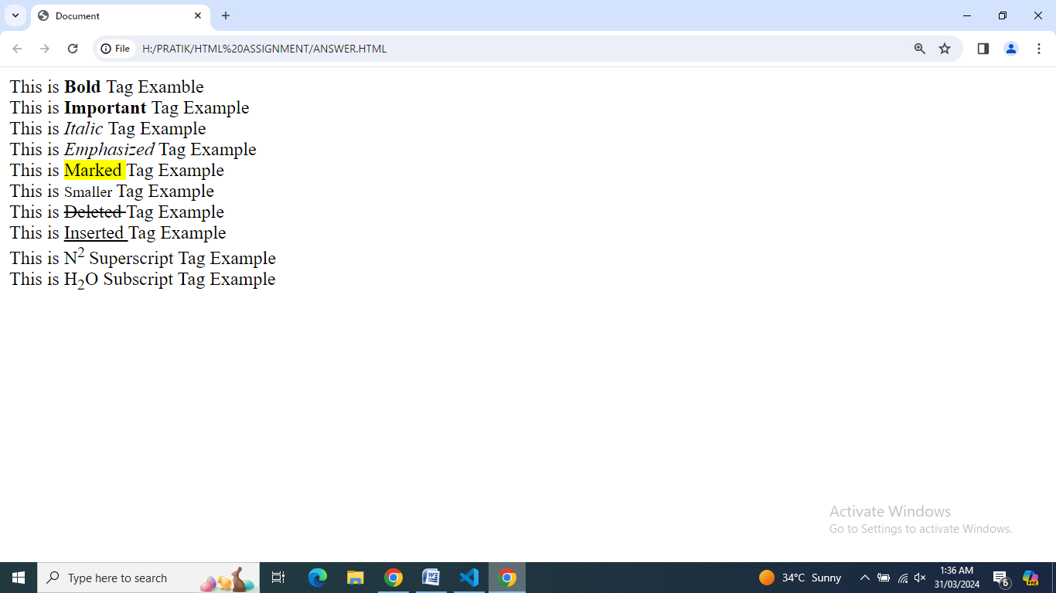

**9. How is Cellpadding different from Cellspacing? With Example.**

**Ans.** Cellpadding is used to set space inside the cell and Cellspacing is used to set space outside the cell in Table. Effect of both are visible when Table Border is must greater than 0.

**Code :**

<!DOCTYPE html>

<html lang="en">

<head>

    <meta charset="UTF-8">

    <meta name="viewport" content="width=device-width, initial-scale=1.0">

    <title>Document</title>

</head>

<body>

    <table border="2" cellpadding="10" cellspacing="20">

        <tr>

            <td>Row 1, Column 1</td>

            <td>Row 1, Column 2</td>

            <td>Row 1, Column 3</td>

            <td>Row 1, Column 4</td>

        </tr>

        <tr>

            <td>Row 1, Column 1</td>

            <td>Row 1, Column 2</td>

            <td>Row 1, Column 3</td>

            <td>Row 1, Column 4</td>

        </tr>

    </table>

</body>

</html>

**Output :**

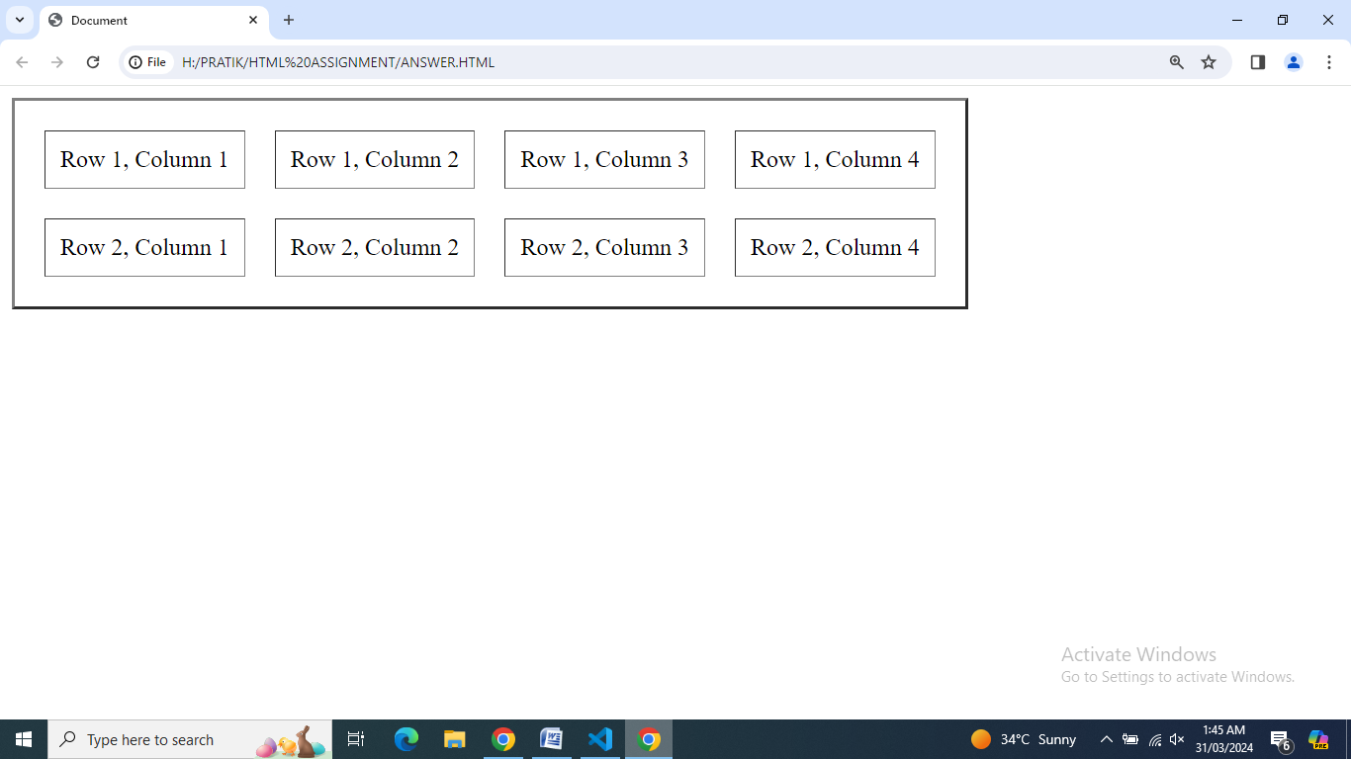

**10. How can we club two or more rows or columns into a single row or column in an HTML table? With Example.**

**Ans.** Rowspan is used to club two or more rows into a single row and Colspan is

used to culb two or more column into a single column in HTML.

**Code :**

<!DOCTYPE html>

<html lang="en">1

<head>

    <meta charset="UTF-8">

    <meta name="viewport" content="width=device-width, initial-scale=1.0">

    <title>Document</title>

</head>

<body>

    <table border="2" cellpadding="10" cellspacing="20">

        <tr>

            <td rowspan="2">Row 1 & 2, Column 1<br>[Rowspan = 2]</td>

            <td>Row 1, Column 2</td>

            <td>Row 1, Column 3</td>

            <td>Row 1, Column 4</td>

        </tr>

        <tr>

            <td colspan="2">Row 2, Column 2 & 3 [ Colspan = 2 ]</td>

            <td rowspan="2">Row 2 & 3, Column 4 <br>[ Rowspan = 2 ]</td>

        </tr>

        <tr>

            <td>Row 2, Column 1</td>

            <td>Row 2, Column 2</td>

            <td>Row 2, Column 3</td>

        </tr>

    </table>

</body>

</html>

**Output :**

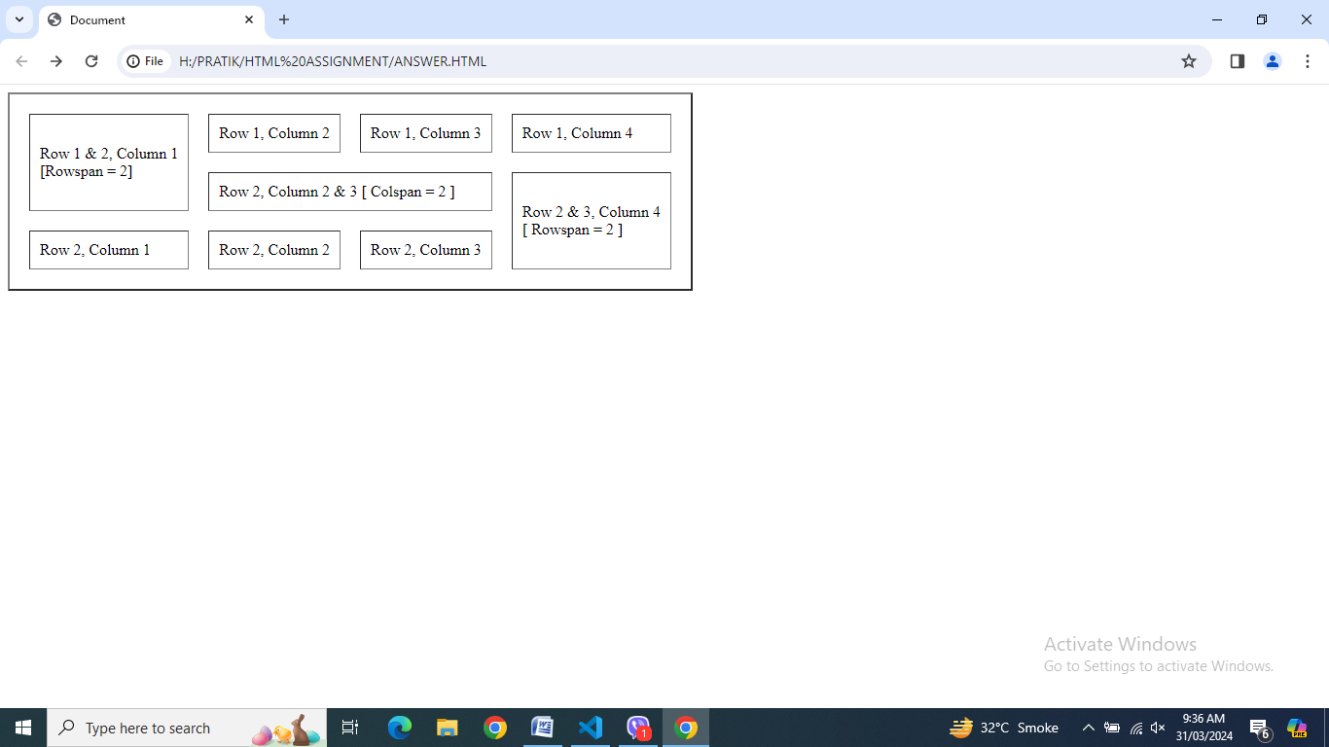

**11. What is the difference between a block-level element and an inline element?**

**Ans.** Block-level element always starts on a new line while inline element dose not start on a new line.

Block level elements occupy the space of whole row while Inline elements occupy the space of content.

**Code :**

<!DOCTYPE html>

<html lang="en">

<head>

    <meta charset="UTF-8">

    <meta name="viewport" content="width=device-width, initial-scale=1.0">

    <title>Document</title>

</head>

<body>

    <h1>

        <p style="color: yellow; background-color: blue;">My mother has <span

                style="color:blue; background-color: yellow; font-weight:bold;">blue</span>

            eyes and my father has <span style="color:brown; background-color: skyblue;

font-weight:bold;">brown</span>

            eyes.</p>

    </h1>

    <h2>

        <p style="background-color: yellow;">My mother has <span

                style="background-color:skyblue;font-weight:bold;">black</span>

            eyes and my father has <span style="color:blue; background-color:aquamarine ;

font- weight:bold;">blue</span>

            eyes.</p>

    </h2>

</body>

</html>

**Output :**

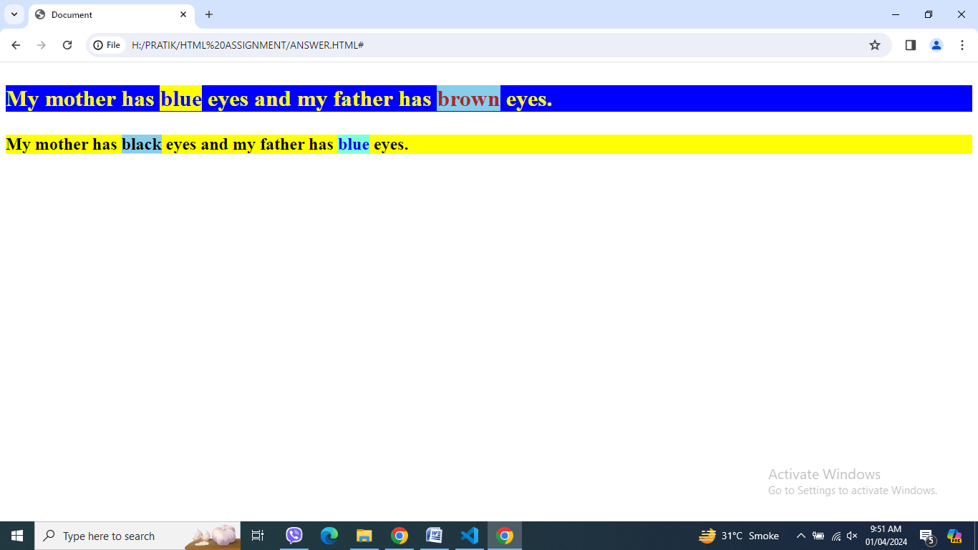

**12. How to create a Hyperlink in HTML? With Example.**

**Ans.** Anchor tag is used with hypertext reference to create Hyperlink in HTML.

**Code :**

<!DOCTYPE html>

<html lang="en">

<head>

    <meta charset="UTF-8">

    <meta name="viewport" content="width=device-width, initial-scale=1.0">

    <title>Document</title>

</head>

<body>

    <h2><a href="https://www.tops-int.com/">Tops Technologies</a></h2>

</body>

</html>

**Output :**

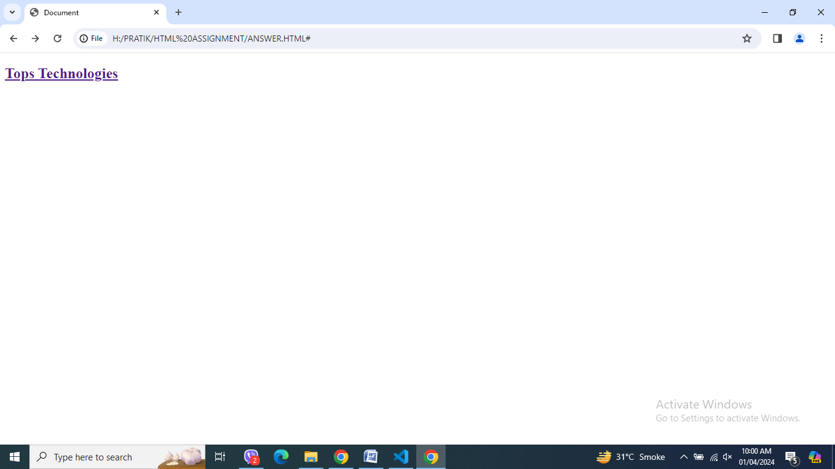

**13. What is the use of an iframe tag? With Example.**

**Ans.** Iframe tag is used to create one or more iframe in a single window to show one or more HTML page in a single page.

**Code :**

<!DOCTYPE html>

<html lang="en">

<head>

    <meta charset="UTF-8">

    <meta name="viewport" content="width=device-width, initial-scale=1.0">

    <title>Document</title>

</head>

<body>

    <iframe src="q-21.html" height="400" width="800" title="Iframe Example"></iframe>

    <iframe src="IMAGE/img2.jpg" height=200" width="500" title="Iframe Example"></iframe>

</body>

</html>

**Output :**

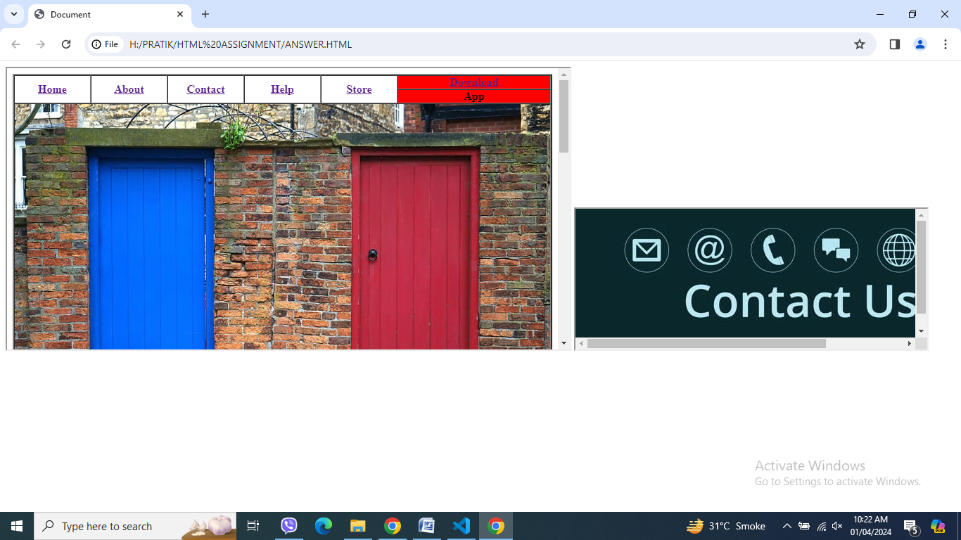

**14. What is the use of a span tag? Explain with example?**

**Ans.** Span tag is used to highlight any part of the text with font color or background

color.

**Code :**

<!DOCTYPE html>

<html lang="en">

<head>

    <meta charset="UTF-8">

    <meta name="viewport" content="width=device-width, initial-scale=1.0">

    <title>Document</title>

</head>

<body>

    <h1>

        <p style="color: white; background-color: blue;">My first Computer was<span

                style="color:red; background-color: yellow; font-weight:bold;"> 486 Computer </span>

            in 1996.

        </p>

    </h1>

</body>

</html>

**Output :**

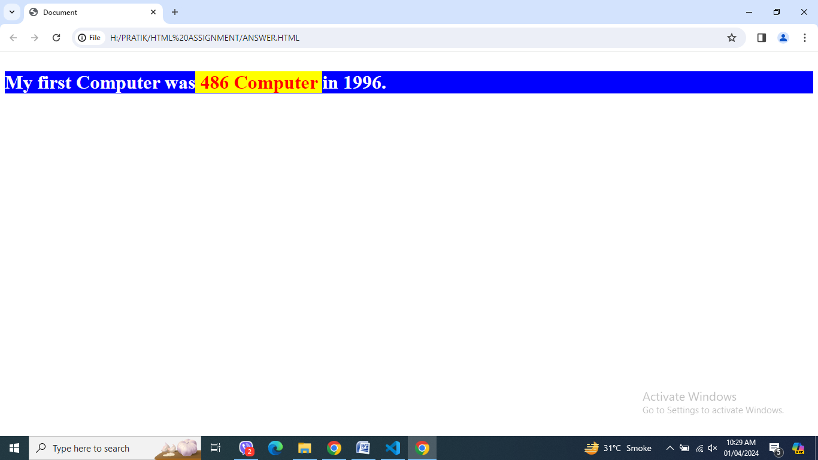

**15. How to insert a picture into a background image of a web page? With Example.**

**Ans.** Background element is used in body tag to insert a picture into a background image of a web page.

**Code :**

<!DOCTYPE html>

<html lang="en">

<head>

    <meta charset="UTF-8">

    <meta name="viewport" content="width=device-width, initial-scale=1.0">

    <title>Document</title>

</head>

<body background="bkg.png">

    <h1>

        <p style="color: red; background-color: yellow;">My first Computer was<span

                style="color:white; background-color: blue; font-weight:bold;"> 486 Computer

</span> in 1996.

        </p>

    </h1>

</body>

</html>

**Output :**

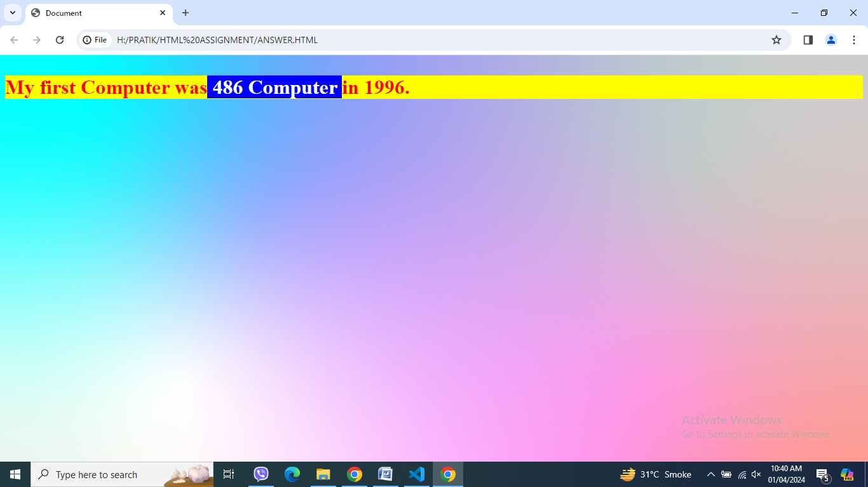

**16. How are active links different from normal links?**

**Ans.** **Normal Link** is a hyperlink which is not yet clicked by the user. By default the normal link will be in blue color with underline.

**Code of Normal Link :**

<!DOCTYPE html>

<html lang="en">

<head>

    <meta charset="UTF-8">

    <meta name="viewport" content="width=device-width, initial-scale=1.0">

    <title>Document</title>

</head>

<body>

    <h2>This is a Link</h2>

    <h3>Click here to visit → <a href="https://www.tutorialspoint.com/">Tutorialspoint</a>

    </h3>

</body>

</html>

**Output of Normal Link :**

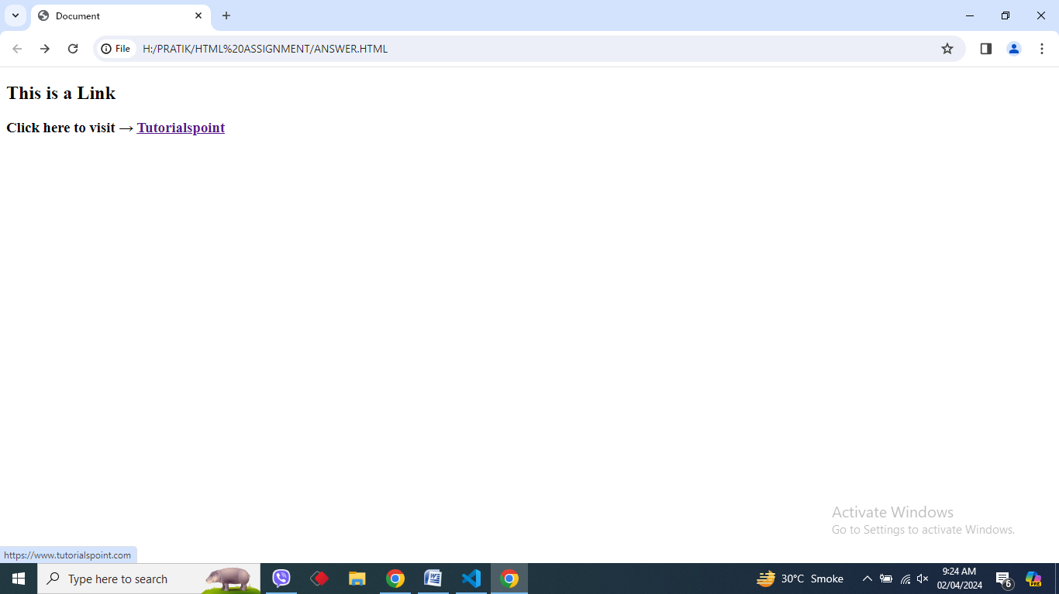

An **Active Link** is a type of hyperlink which is currently being interacted with the user. Whenever the user hold the mouse button on the link and not released yet or if right clicked on it, it will change its color in red.

**Code of Active Link :**

<!DOCTYPE html>

<html lang="en">

<head>

    <meta charset="UTF-8">

    <meta name="viewport" content="width=device-width, initial-scale=1.0">

    <title>Document</title>

    <style>

        a:hover {

            color: red;

            background-color: transparent;

            text-decoration: underline;

        }

        a:active {

            color: yellow;

            background-color: transparent;

            text-decoration: underline;

        }

    </style>

</head>

<body>

    <h2>This is a Link</h2>

    <h3>Click here to visit → <a href="https://www.tutorialspoint.com/">Tutorialspoint</a>

    </h3>

</body>

</html>

**Output of Active Link :**

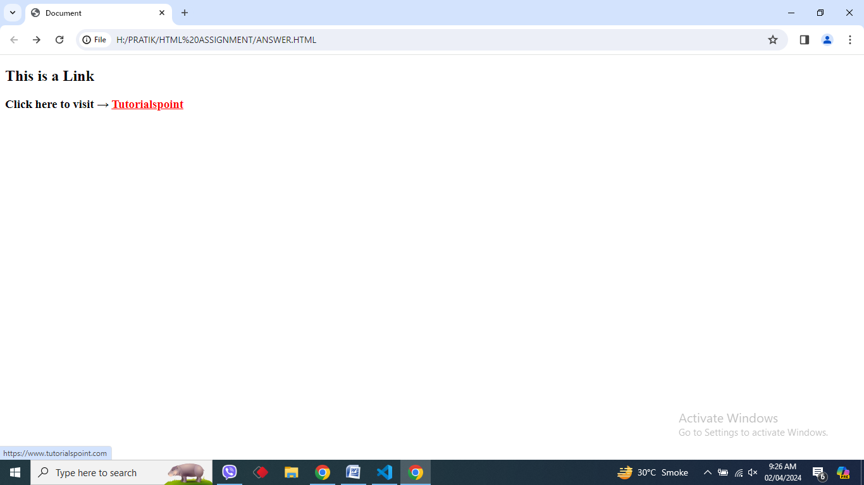

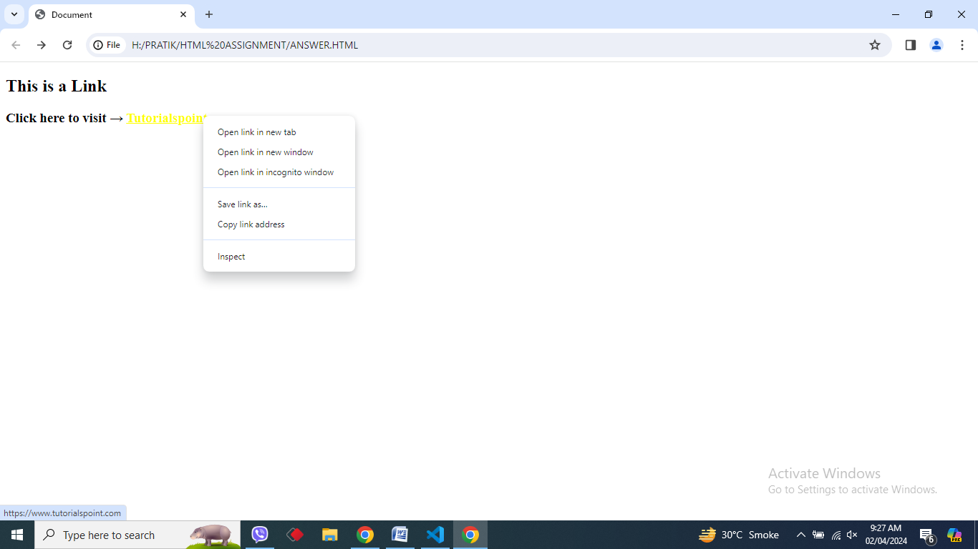

**17. What are the different tags to separate sections of text?**

**Ans.** We separate a section of texts in HTML using the below tags:

* <br> tag – It is used to separate the line of text. It breaks the current line and shifts the flow of the text to a new line.
* <p> tag–This tag is used to write a paragraph of text.
* <blockquote> tag–This tag is used to define large quoted sections.

**Code :**

<!DOCTYPE html>

<html lang="en">

<head>

    <meta charset="UTF-8">

    <meta name="viewport" content="width=device-width, initial-scale=1.0">

    <title>Document</title>

</head>

<body>

    <blockquote>

        <p>Lorem ipsum dolor sit, amet consectetur adipisicing elit. Maiores hic, consectetur tenetur reprehenderit

            quasi incidunt, excepturi enim corporis, similique voluptas minima eaque. Dolore tempore accusantium maxime

            ipsum! Ratione, deserunt libero! Aspernatur impedit cum, eaque veritatis provident doloribus dignissimos

            odit voluptate corrupti corporis quasi in reprehenderit molestiae aut, ipsam similique? Placeat odit ad

            alias incidunt ipsa at porro odio suscipit reprehenderit similique quasi dolorum eum, earum autem,

            laboriosam deserunt amet itaque corporis. Maxime sint sunt pariatur ab tempora laboriosam quis ipsam

            necessitatibus! <br><br>Voluptatum qui rerum quia ab autem accusantium, animi repudiandae odit facilis

            ullam minima deleniti aspernatur quis quo dolorum similique, reprehenderit eaque error! Dicta minima laborum

            blanditiis commodi autem tenetur sed porro facilis, aliquid excepturi labore quam corrupti quisquam velit

            repellendus voluptatum corporis quasi quo dolorem ullam perferendis maxime! Perspiciatis quasi quas, eius,

            distinctio, voluptas earum delectus illum vitae ducimus molestiae fuga. Qui quod minima cumque voluptates

            fugit ratione laboriosam nam minus laudantium illo. <br><br>Officia perferendis molestiae iste, dicta esse

            voluptates suscipit ut autem harum, obcaecati iusto alias pariatur molestias est corporis ullam! Quae a

            mollitia quam esse, pariatur quod maiores repudiandae atque quaerat quos obcaecati quasi cupiditate natus

            possimus quis magnam minus laudantium. Odit recusandae consequuntur facilis officia esse vel, fuga error

            exercitationem! Dicta sint et quibusdam voluptas, pariatur dolorem tempora repellendus quae quam officia

            nihil, aspernatur cumque numquam aliquid in neque! Rem minima deserunt omnis hic possimus minus obcaecati

            deleniti? Unde, numquam aspernatur ratione, possimus ducimus blanditiis delectus, explicabo repudiandae iste

            doloribus quae animi?

        </p>

    </blockquote>

</body>

</html>

**Output :**

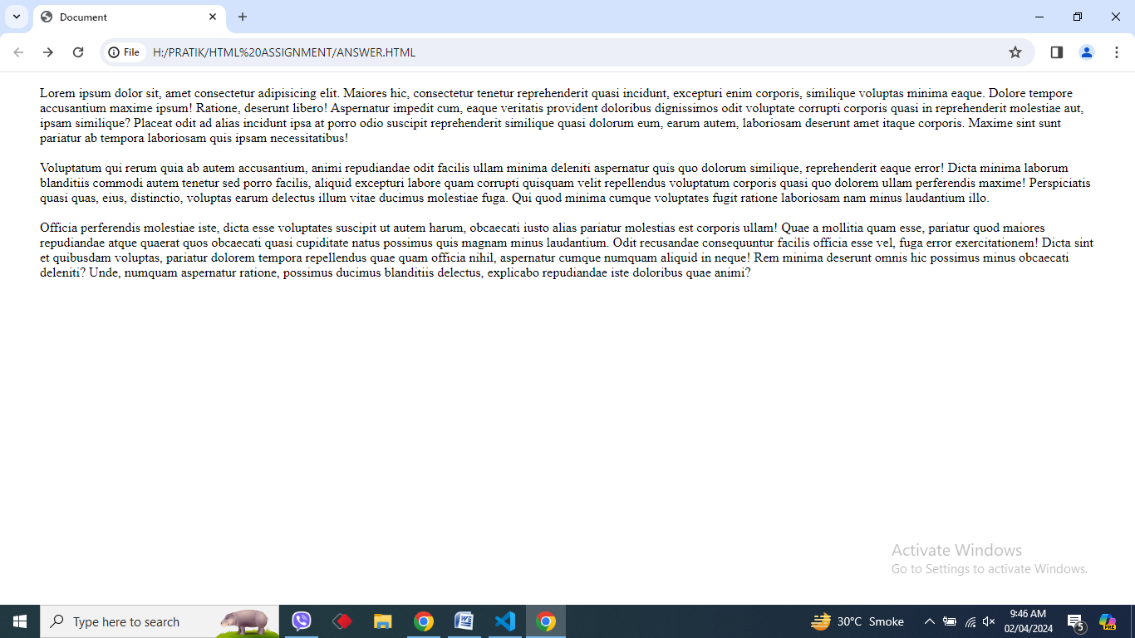

**18. What is SVG?**

**Ans.**

* SVG stands for Scalable Vector Graphics.
* SVG defines vector-based graphics in XML format.
* SVG graphics are scalable, and do not lose any quality if they are zoomed or resized.
* SVG is supported by all major browsers.

**Code :**

<!DOCTYPE html>

<html lang="en">

<head>

    <meta charset="UTF-8">

    <meta name="viewport" content="width=device-width, initial-scale=1.0">

    <title>Document</title>

</head>

<body>

    <blockquote>

        <svg width="300" height="300" style="background-color:aqua ;" xmlns="http://www.w3.org/2000/svg">

            <circle cx="150" cy="150" r="80" stroke="red" stroke-width="4" fill="pink" />

        </svg>

</body>

</html>

**Output :**

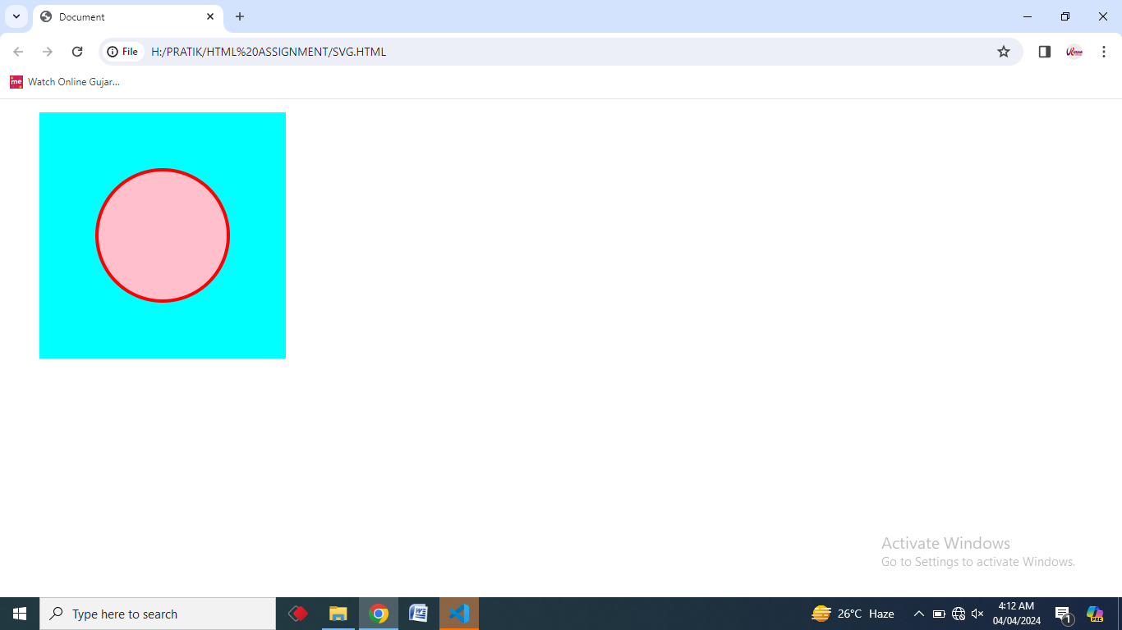

**19. What is difference between HTML and XHTML?**

**Ans.**  HTML (Hyper Text Markup Language) and XHTML (Extensible Hyper Text Markup Language) are both markup languages used for creating and displaying web pages.

The main difference between them is the syntax and structure;

HTML is more lenient in its syntax, while XHTML has a more strict syntax and follows XML rules.

The Most Important Differences from HTML

* <!DOCTYPE> is **mandatory**
* The xmlns attribute in <html> is **mandatory**
* <html>, <head>, <title>, and <body> are **mandatory**
* Elements must always be **properly nested**
* Elements must always be **closed**
* Elements must always be in **lowercase**
* Attribute names must always be in **lowercase**
* Attribute values must always be **quoted**
* Attribute minimization is **forbidden**

**Code :**

<!DOCTYPE html PUBLIC "-//W3C//DTD XHTML 1.1//EN" "http://www.w3.org/TR/xhtml11/DTD/xhtml11.dtd">

<html xmlns="http://www.w3.org/1999/xhtml">

<head>

    <title>Title of document</title>

</head>

<body>

    <b><i>Some text</i></b>

    <p>This is a paragraph</p>

    A break: <br />

    A horizontal rule:

    <hr />

    An image: <img src="happy.PNG" height="50px" alt="Happy face" /><br />

    Check Box : <input type="checkbox" name="vehicle" value="car" checked="checked" /><br />

    Text Box :<input type="text" name="lastname" disabled="disabled" />

</body>

</html>

**Output :**

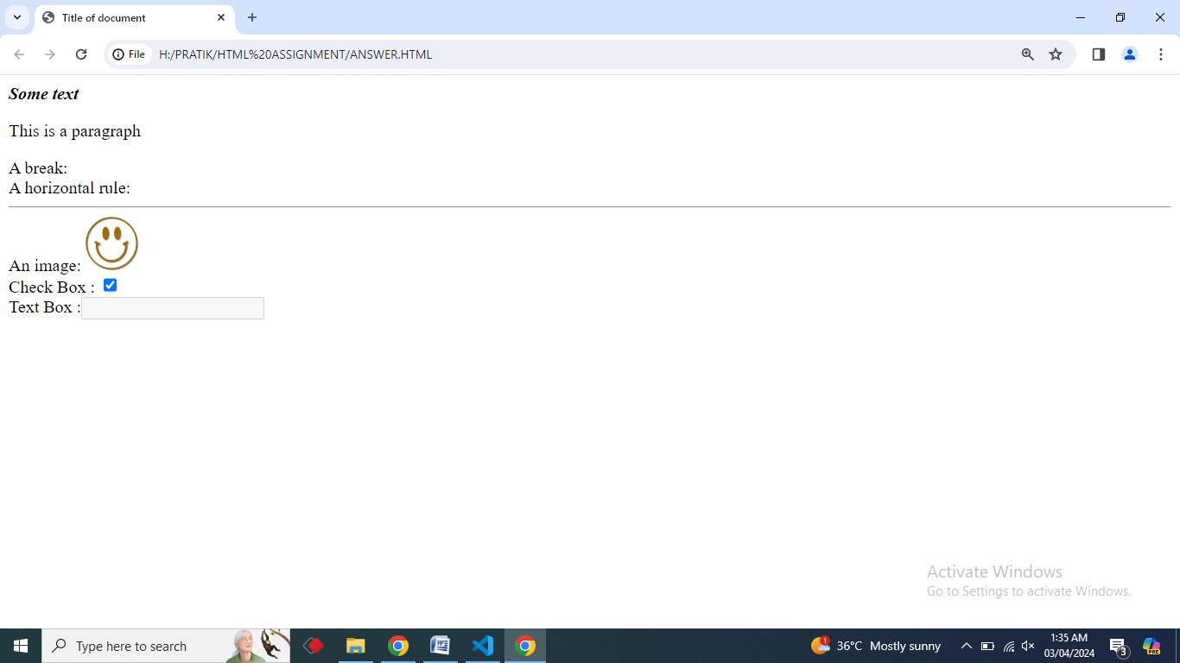

**20. What are logical and physical tags in HTML?**

**Ans.**

**Physical Tag :** These tags are used to provide the actual physical formatting to

the text.

For Ex. : <b>, <i>, <u>, <sub>, <sup> etc…

**Code :**

<!DOCTYPE html>

<html>

<head>

    <title>Physical Tags</title>

</head>

<body>

    <h1> Physical Tags </h1>

    Text without any formatting <br>

    <b> GeeksforGeeks- This is Bold text </b> <br>

    <i> GeeksforGeeks- This is Italic text </i> <br>

    <u> GeeksforGeeks- This is underlined text</u> <br>

    1<sup>st </sup> <br>

    H<sub>2</sub>O <br>

</body>

</html>

**Output :**

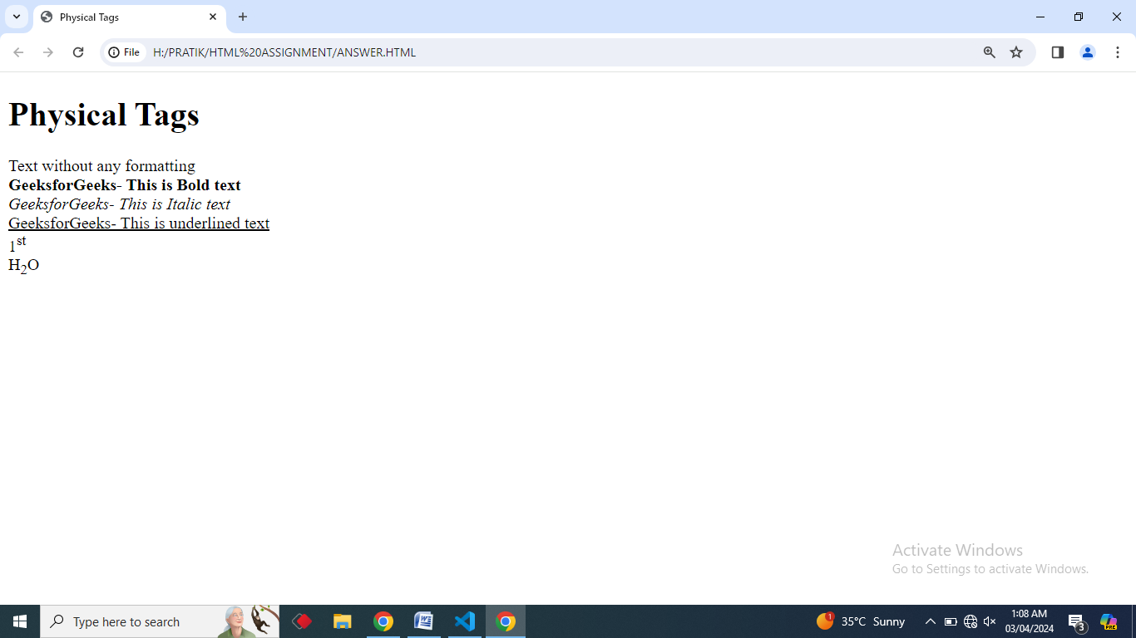

**Logical Tag :** These tags are used to display the text according to the logical style.

For Ex. : <blockquote> <del>, <ins>, <pre>, <strong> etc…

**Code :**

<!DOCTYPE html>

<html lang="en">

<head>

<body>

    <h1> Logical Tags </h1>

    <blockquote cite="https://www.geeksforgeeks.org/">

    A Computer Science portal for geeks. It contains well written, well thought and well

    explained computer science and programming articles, and quizzes.

    </blockquote>

    <del> This contains deleted content.</del>

    <ins> Newly inserted content.</ins>

    <pre>    Dear User,

        <strong>Congratulations !! </strong>

        We are delighted to inform you that you are going to be part of GfG journey.

        Thanks,

        GfG Team

    This is a predefine formatted text </pre>

</body>

</html>

**Output :**

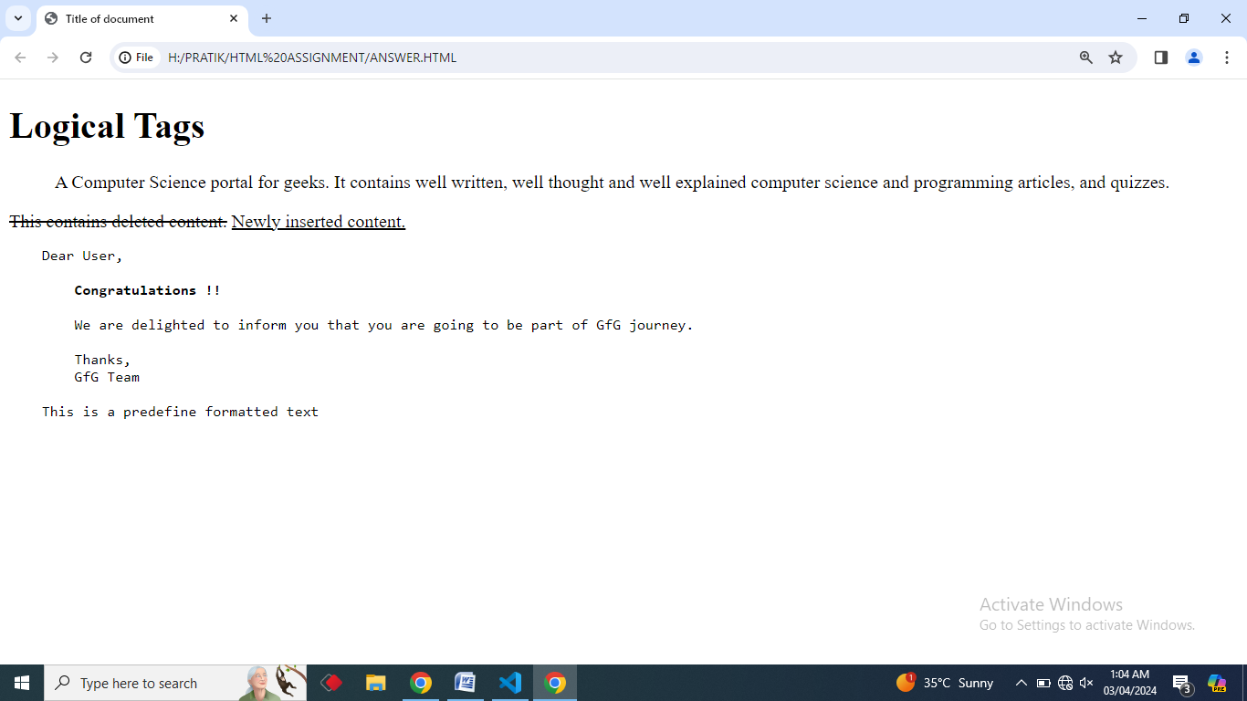

**Q. 21 Create below example using only HTML tags without CSS.**

**Code :**

<!DOCTYPE html>

<html lang="en">

<head>

    <meta charset="UTF-8">

    <meta name="viewport" content="width=device-width, initial-scale=1.0">

    <title>Document</title>

</head>

<body>

    <table cellpadding="00" cellspacing="00" width="100%" border="2">

        <tr>

            <th width="14%" rowspan="2"><a href="">Home</a></th>

            <th width="14%" rowspan="2"><a href="">About</a></th>

            <th width="14%" rowspan="2"><a href="">Contact</a></th>

            <th width="14%" rowspan="2"><a href="">Help</a></th>

            <th width="14%" rowspan="2"><a href="">Store</a></th>

            <th width="28%" colspan="2" bgcolor="red"><a href="">Download</a></th>

        </tr>

        <tr>

            <th colspan="2" bgcolor="red">App</th>

        </tr>

        <tr>

            <th colspan="7"><img src="IMG1.jpg" width="100%" height="500px"></th>

        </tr>

        <tr>

            <th colspan="7" bgcolor="pink">Contact us Page</th>

        </tr>

        <tr>

            <th colspan="7"><img src="IMG2.jpg" width="100%" height="300px"></th>

        </tr>

        <tr>

            <th colspan="3" bgcolor="skyblue"><label for="fname">First Name:</label> <input type="text" id="fname"

                    name="fname" required>

            </th>

            <th colspan="4" bgcolor="skyblue"><label for="lname">Last Name:</label> <input type="text" id="lname"

                    name="lname" required>

            </th>

        </tr>

        <tr>

            <th colspan="3" bgcolor="skyblue"><label for="email">E-mail Id :</label> <input type="text" id="email"

                    name="email" required>

            </th>

            <th colspan="4" bgcolor="skyblue"><label for="mobile">Mobile No. :</label> <input type="text" id="mobile"

                    name="mobile" required></th>

        </tr>

        <tr>

            <th colspan="3" bgcolor="skyblue">

                <label for="city">City :</label>

                <select name="city" id="city">

                    <option value="volvo">Ahmedabad</option>

                    <option value="saab">Bhavnagar</option>

                    <option value="opel">Delhi</option>

                    <option value="audi">Surat</option>

                </select>

            </th>

            <th colspan="4" bgcolor="skyblue">Gender :

                <input type="radio" id="male" name="Gender" value="Male" checked>

                <label for="male">Male</label>

                <input type="radio" id="female" name="Gender" value="Female">

                <label for="female">Female</label>

                <input type="radio" id="other" name="Gender" value="Other">

                <label for="other">Other</label>

            </th>

        </tr>

        <tr>

            <th colspan="3"><iframe

                    src="https://www.google.com/maps/embed?pb=!1m18!1m12!1m3!1d3672.723604438949!2d72.60635807444673!3d22.

                    99718911727658!2m3!1f0!2f0!3f0!3m2!1i1024!2i768!4f13.

                    1!3m3!1m2!1s0x395e85c2fc005927%3A0x918e69150ca1c935!2sTOPS%20Technologies!5e0!3m2!1sen!2sin!

                    4v1710952278524!5m2!1sen!2sin"

                    width="100%" height="450" style="border:0;" allowfullscreen="" loading="lazy"

                    referrerpolicy="no-referrer-when-downgrade"></iframe></iframe></th>

            <th colspan="4"><iframe width="100%" height="450"

                    src="https://www.youtube.com/embed/26zASCsIa10?si=UdNDlMTZVD3SJ4Wf" title="YouTube video player"

                    frameborder="0"

                    allow="accelerometer; autoplay; clipboard-write; encrypted-media; gyroscope; picture-in-picture; web-share"

                    allowfullscreen></iframe></th>

        </tr>

    </table>

</body>

</html>

**Output :**

